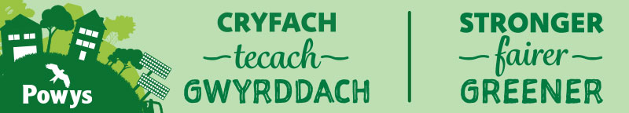
County Councillor Contact Details:
Email: cllr.jackie.charlton@powys.gov.uk
Tel: 07444495633
David Chadwick MP contact details:
Email: david.chadwick.mp@parliament.uk
Jane Dodds MS contact details:

Llangattock County Councillor Report – March 2026

County Councillor Surgery
The Llangattock County Council surgery will now be held monthly at the Repair Café next one due on 28th March. Should you wish to discuss any matters before then, please do not hesitate to get in touch at: cllr.jackie.charlton@powys.gov.uk Tel: 07444495633 I also have a Surgery in Llangynidr will be on the 14th April due to Easter Holiday on the first Monday.

Crickhowell High School
The next stage report is now publicly available using this link:- Cyngor Sir Powys County Council - Agenda for Learning and Skills Scrutiny Committee on Thursday, 19th March, 2026, 10.00 am where you will find all the accompanying reports with results of the extensive engagement undertaken so far. The Learning and Skills Committee will be scrutinising the Cabinet report at 10.00 am on Thursday 19th March. There will be a link to the live recording on the webpage but if you cannot attend on the morning a recording will be available.
At my County Councillor Surgeries in February, I had a number of visitors and was able to update all on the different stages of the consultation and engagement and provide background information on why we need to undertake this transformation in Powys. All the comments have been lodged with our Education Transformation Team. I have also responded to several emails sent from those who were unable to come along in person.
No decision is being sought at this stage regarding future delivery models. The council will continue to strengthen the existing Chweched Powys Sixth, and the report seeks approval to continue engagement with learners, families, schools, colleges and employers over the next 12 months.
The proposed programme of work, which has been informed by one of the largest engagement exercises carried out on education in the county, includes:
- Continuing to strengthen the existing Chweched Powys Sixth model for current learners.
- Establishing a new Future Pathways Board with Further Education, Higher Education, employers and the Regional Skills Partnership.
- Creating a governor steering group and an ALN post-16 working group to shape improved pathways for learners.
- Engagement with primary schools and employers later in 2026 to ensure future pathways reflect local needs and the county’s future economy.

I would like to extend thanks to Tim Jones, Chair of the Community Council, for sitting in on the conversation with those who attended the surgery on 28th February.

Livestock Deaths and Speeding on Common Land
I have located contacts and will be liaising with the Police this month. No response from the Minister yet from the joint letter sent with MP and MS. Still awaiting the signs!!

PCSO Update
I have now had confirmation that two PCSOs have recently been recruited to the Brecon area, and they commence their training in Police headquarters from 30th March. One of the PCSO’s will be designated to the Crickhowell area and the other will be designated for Brecon. The training will take approximately three months, so an exact start date is not yet clear. In the meantime, we have been promised cover when appropriate from Brecon. I have asked for a visit from a police officer for my April County Council Surgery in Llangynidr to meet some of the Speed Watch volunteers who continue to do great work on Crawnon Road and Forge Road. We have previously had very good support from the PCSO who adds a level of authority when volunteers are on the road.

Active Travel
Work has started. The team is ahead of schedule. Sadly, we have had to contact the contractor a couple of times because the lights stop working. The pedestrian link is used and pleased to see this has been organised for those who cannot use the alternative path because of the Kissing Gates. We do ask for some patience whilst this work is undertaken.

Flooding and Section 19 Update
The Section 19 Report is now complete and on it’s way to the appropriate authorities. Confirmation has been received from Powys County Council that funding sought for flood alleviation work in Llangattock has been approved. Flood Wardens (including Gail Jones Councillor) attended the Flood Governance Board meeting and were able to put forward all the relevant information for Llangattock. Our Flood Wardens are highly respected and other authorities, such as Monmouthshire, want to learn from our experiences after the major flooding in Monmouth and Skenfrith this autumn. It was agreed that town and community councils have a major role to play in resilience in our communities.

