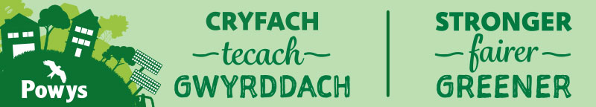
County Councillor Contact Details:
Email: cllr.jackie.charlton@powys.gov.uk
Tel: 07444495633
David Chadwick MP contact details:
Email: david.chadwick.mp@parliament.uk
Jane Dodds MS contact details:
Email: Jane.Dodds@Senedd.Wales
County Councillor Report - January 2025 Llangattock
- County Councillor Surgery – Future Surgery days will be on bi monthly Saturdays with the Repair Café. This works well and has been very successful. If you would like a more private discussion will be available in the Sardis Chapel Llangynidr or contact me at anytime and we can arrange a meeting. See contact details above.
- Residents Car Park – Still an issue. Becoming very frustrated.
- Powys Flood Group – I have been liaising with the Flood Group and Tim Jones on this to make sure all the concerns are responded to. Most have been. Funding application for Llangattock Nant Onneu has been submitted. The fund is to provide money to progress study work leading to the completion of an outline business case. A long way to go yet and will obviously update on success or otherwise. Graham Astley said the data and photos collected by Llangattock Flood Wardens and the Community Council was excellent evidence and has asked that I pass on his thanks to you all.
- Active Travel – Am meeting with Vincent Goodwin later this week to discuss the tweaking needed for pedestrian lights, which is a technical issue. Hoping to get feedback on the next stages. I understand we are still waiting for the Memorandum of Understanding to be signed by UK government on all the Levelling Up Funds so still a level of nervousness although constantly being reassured that it will be OK.
- Technical Advice Group Feedback – I have given some feedback on this already. We are awaiting the next meeting date. I believe there is some nervousness from the Duke Of Beaufort’s agent on the discussions we have had but all at the meeting were clear that we need full engagement and links to the community. A separate report will be shared with the Community Council to put on file. Also sharing with Llangynidr Community Council.
- Budget – Since meeting in November a lot of work has been undertaken on the budget and a draft balanced budget was agreed by the Cabinet earlier this month. This draft will now be scrutinised by each Scrutiny Committee. All members of the council have seen the draft and it is publicly available o the Powys website as well as being in the local press and on social media.
- Powys Sustainable Resource Strategy – There is a 12 week engagement process for the Resource Strategy which covers all of the recycling and future focus to get to zero waste by 2020 which is a Welsh Government target. Waste is anything that has to go to Energy for Waste as it cannot be recycled. Wales is second in the world for successful recycling, Austria is first. There is a real push now to become first. Powys does play its part and is on target to hit close to 69% recycling but need to get to 70%. There are also new procedures in place to make visits to the Household Recycling Centres easier from April 2025. A new booking system is being designed so you can plan your slot at the centre enabling everyone to have help to put items into correct recycling ins at the centre and prevent queues. It is also much better for those who have accessibility issues. DIY waste will be charged for from April 2025 as well. This will be for large items of waste such as kitchen and bathroom items associated with replacements in the home, as well as other larger items including replacement windows, flooring and cement.
- Bus and Transport – A consultation process started at the end of 2024 for the proposed new timetables. There still appears to be a gap earlier in the morning in Llangynidr. I will take any comment to the team should you feel there is a demand for an early bus to Brecon

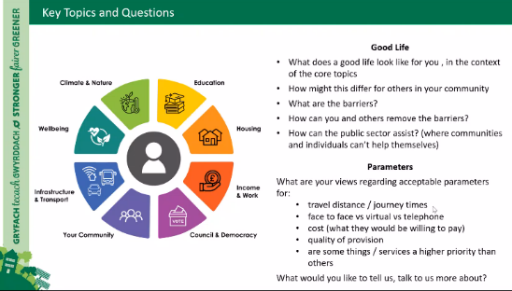
- Sustainable Powys
Communication and updates.
Sustainable Powys is now fully embedded into the council activity and more work is being undertaken to engage with town and community councils through the spring. Please keep an eye on activity and information flow from the council to the Clerk. There was a successful meeting in Brecon in December which the Chair attended. There are more sessions planned during 2025.

